**LAB 9**

**OBJECTIVE**

To be familiar with XML and XSL

**DESCRIPTION**

XML stands for Extensible Markup Language. It is a text-based markup language derived from Standard Generalized Markup Language (SGML). XML tags identify the data and are used to store and organize the data, rather than specifying how to display it like HTML tags, which are used to display the data.

XSL is a family of recommendations for defining XML document transformation and presentation. It consists of three parts:

**XSL Transformations (XSLT)** : a language for transforming XML

**The XML Path Language (XPath)** : an expression language used by XSLT (and many other languages) to access or refer to parts of an XML document

**XSL Formatting Objects (XSL-FO)** : an XML vocabulary for specifying formatting semantics

**XML**

<?xml version="1.0" encoding="UTF-8"?>

<?xml-stylesheet type="text/xsl" href="bookstore.xsl"?>

<bookstore>

<book>

<title>Machine Learning</title>

<price>रू 5600</price>

<author>Tirtha Raj Poudel</author>

<isbn>55674</isbn>

</book>

<book>

<title>Neural Networks</title>

<price>रू 3400</price>

<author>Tirtha's Son</author>

<isbn>38992</isbn>

</book>

<book>

<title>Recipe of Potato</title>

<price>रू 1200</price>

<author>Mrs. Poudel</author>

<isbn>43216</isbn>

</book>

</bookstore>

**XSL**

<?xml version="1.0" encoding="UTF-8"?>

<xsl:stylesheet xmlns:xsl="http://www.w3.org/1999/XSL/Transform"

version="1.0">

<xsl:template match="/">

<html>

<body>

<h2>Book List</h2>

<table border="2">

<tr>

<td>Title</td>

<td>Price</td>

<td>Author</td>

<td>ISBN</td>

</tr>

<xsl:for-each select="bookstore/book">

<tr>

<td><xsl:value-of select="title"/></td>

<td><xsl:value-of select="price"/></td>

<td><xsl:value-of select="author"/></td>

<td><xsl:value-of select="isbn"/></td>

</tr>

</xsl:for-each>

</table>

</body>

</html>

</xsl:template>

</xsl:stylesheet>

**OUTPUT**

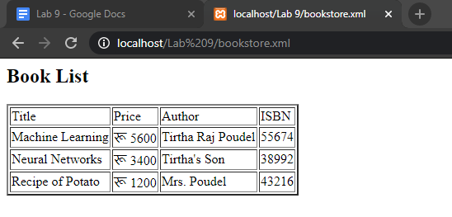

**SUMMARY**

In this lab, we got familiar with XML and XSL. We created an XML file to store some data and then wrote a XSL code to render the XML data and style it. XSL syntax was really complex to deal with at first.

**COMMENT**